# CSC 430 – Database Management Systems

Exam 1

Name: 100 points

Instructions:

* Put your name in the appropriate place at the top of this page;
* Do not use red ink;

# Closed books and notes;

* **No electronic devices are allowed;**
* You will only receive points for a question if you attempt to answer it;
* For full credit, list all formulas that provide the basis for calculations and show all work;
* If you aren't clear about a question, state your assumptions first followed by your answer;
* When finished with the exam, read and sign the pledge at the bottom of this page.

Good luck!

“On my honor as a Louisiana Tech student, I have neither given nor received unauthorized assistance on this academic work.”

Student signature

**Section A: Multiple-choice questions.** Total: 10 points.

Please, circle a single correct option. Each question is worth 2 points.

1. Select correct statement(s):
   1. Database is a collection of related data.
   2. DBMS is a general-purpose software system that allows users to create and maintain a database.
   3. Database represents some aspects of mini-world.
   4. Database system consists of DBMS software and database itself.
   5. Database is a logically coherent collection of data with inherent meaning.
   6. All of the above.
   7. Only a, b, c.
   8. Only c, d, e.
2. Select correct statement(s):
   1. Physical data independence means that changes of internal schema will force changes of conceptual schema.
   2. Logical data independence means that changes of conceptual schema will not force changes of external schema.
   3. Physical data independence means that changes of internal schema will not force changes of conceptual schema.
   4. Logical data independence means that changes of conceptual schema will force changes of external schema.
   5. All of above.
   6. Only a, b.
   7. Only b, c.
   8. Only a, d.
3. Select correct statement(s):
   1. Relationship is an object of the mini-world represented in the database.
   2. Entity is a particular property that describes an attribute.
   3. Attribute relates two or more distinct relationships with specific meaning.
   4. Each entity type must have one or more attributes whose values are distinct for each individual entity in the entity set.
   5. All of the above.
   6. None of the above.
   7. Only a, b.
   8. Only b, c.
4. Select correct statement(s):
   1. The state of a relation is a set of tuples.
   2. Tuple is an ordered set of values.
   3. Each tuple value must be from the domain of the attribute.
   4. Values in tuple can be atomic, composite or multivalued.
   5. All of the above.
   6. None of the above.
   7. Only a, b, c.
   8. Only b, c, d.
5. Select correct statement(s):
   1. Insert operation can violate all four schema-based constraints.
   2. Delete operation can violate entity integrity and referential integrity constraints.
   3. Modify operation cannot violate any schema-based constraints when updating primary key or foreign key attributes.
   4. All of the above.
   5. None of the above.
   6. Only a, b.
   7. Only b, c.
   8. Only a, c.

**Section B: Open-ended questions.** Total: 35 points.

To get full points provide a complete answer, be specific and concise.

1. **(5 pts)** Describe the difference between database schema and database state.
2. **(10 pts)** Describe cardinality ratio constraint and participation constraint on *relationships*.
3. **(10 pts)** Describe disjointness constraint and completeness constraint on *specializations*.
4. **(10 pts)** List and describe the four relational schema-based constraints.

**Section C: Practical questions.** Total: 55 points.

1. **(10 pts)** Define which (if any) schema-based constraints are violated by provided operations. Justify your answer. Database schema and state are provided for your reference.
   1. Insert following tuple into EMPLOYEE relation:

<‘Bruce’, ‘R’, ‘Johnson’, ‘NULL’, ‘March-6-1977’, ‘6357 Windswept, Katy, TX’, ‘F’, 28000, ‘987654321’, 9>

* 1. Insert following tuple into DEPARTMENT relation:

<‘Production’, 1, ‘943775543’, ‘2007-10-01’>

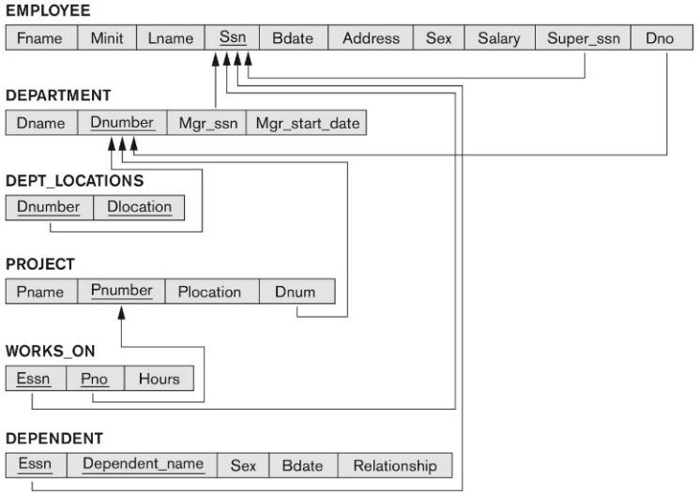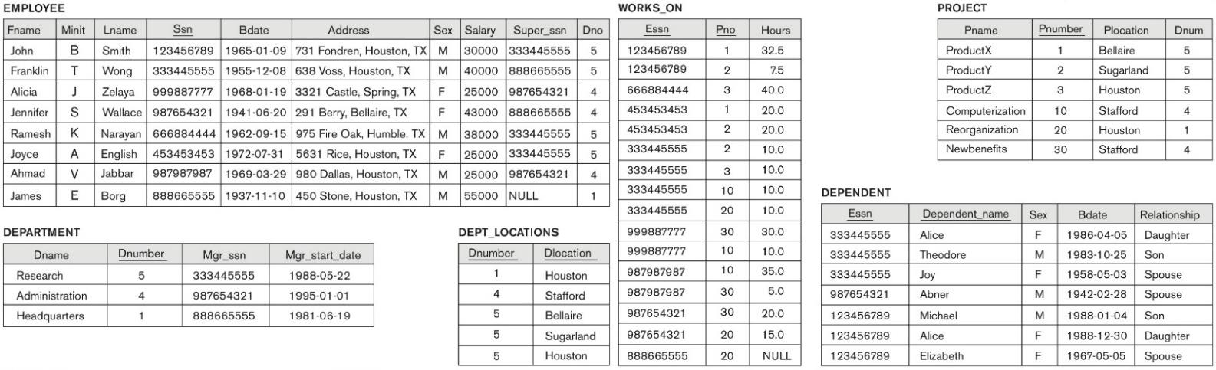

1. **(15 pts)** Consider the following relations for a database that keeps track of vehicle sales at a car dealership. The OPTION relation refers to some optional equipment installed on a vehicle. Specify the foreign keys and referential integrity constraints for this schema.

|  |  |  |  |  |
| --- | --- | --- | --- | --- |
| **CAR** | | | | |
| Vin | Model | Manufacturer | Price | Option_serial_no |

|  |  |  |
| --- | --- | --- |
| **OPTION** | | |
| Serial_no | Option_name | Option_price |

# CUSTOMER

|  |  |  |  |
| --- | --- | --- | --- |
| Ssn | Name | Phone | Address |

|  |  |  |
| --- | --- | --- |
| **SALESPERSON** | | |
| Salesperson_id | Name | Branch |

|  |  |  |  |  |
| --- | --- | --- | --- | --- |
| **BRANCH** | | | | |
| Branch_id | Branch_name | Phone | Address | Region |

|  |  |  |  |  |
| --- | --- | --- | --- | --- |
| **SALE** | | | | |
| Salesperson_id | Vin | Ssn | Date | Sale_price |

1. **(15 pts)** Map the following EER diagram to a relational schema. Define primary keys, foreign keys, and show referential integrity constraints.

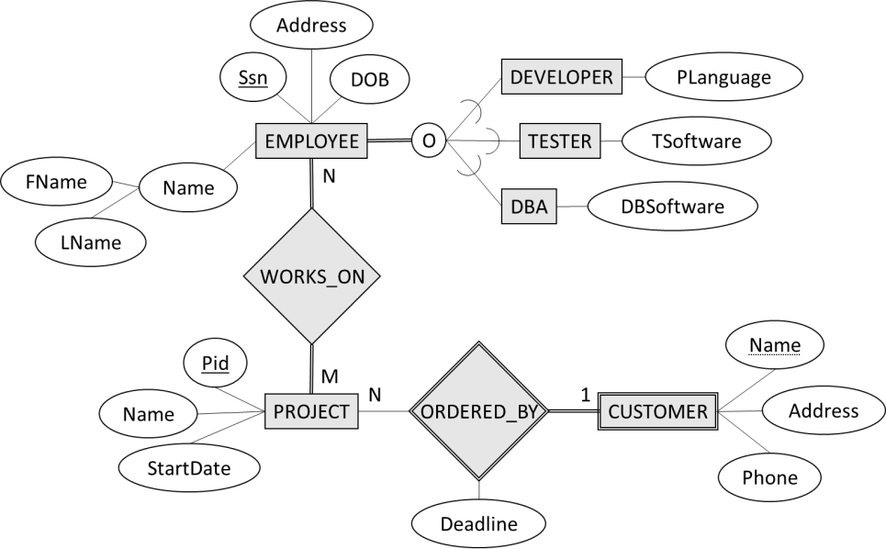

1. **(15 pts)** Using relational algebra operations, construct a query that satisfies the provided description. Show the resulting relation (table with tuples). Database state is provided for your reference.
   1. Retrieve first name and last name of all employees who work for projects located in ‘Houston’.
   2. Retrieve first name, last name and Ssn of employees who work in the ‘Research’ department on a project located in ‘Sugarland’ and whose salary is more than $26,000.

